IndianPlayers.js
import React from "react";

function IndianPlayers() {

const players = [
"Virat",
"Rohit",
"Gill",
"Rahul",
"Hardik",
"Jadeja"
];

const [odd1, even1, odd2, even2, odd3, even3] = players;

const T20players = [
"Surya",
"Tilak",
"Rinku"
];

const RanjiPlayers = [
"Pujara",
"Rahane",
"Karun"
];

const mergedPlayers = [...T20players, ...RanjiPlayers];

return (

<div>

<h2>Odd Team Players</h2>

<ul>
<li>{odd1}</li>
<li>{odd2}</li>
<li>{odd3}</li>
</ul>

<h2>Even Team Players</h2>

<ul>
<li>{even1}</li>
<li>{even2}</li>
<li>{even3}</li>
</ul>

<h2>Merged Players</h2>

<ul>
{
mergedPlayers.map((player, index) => (
<li key={index}>{player}</li>
))
}
</ul>

</div>
);
}

export default IndianPlayers;

ListofPlayers.js
import React from "react";

function ListofPlayers() {

const players = [
{ name: "Virat", score: 95 },
{ name: "Rohit", score: 88 },
{ name: "Gill", score: 65 },
{ name: "Rahul", score: 55 },
{ name: "Hardik", score: 80 },
{ name: "Jadeja", score: 45 },
{ name: "Ashwin", score: 78 },
{ name: "Bumrah", score: 25 },
{ name: "Shami", score: 60 },
{ name: "Siraj", score: 72 },
{ name: "Kuldeep", score: 50 }
];

const below70 = players.filter(player => player.score < 70);

return (
<div>
<h2>List of Players</h2>

<h3>All Players</h3>

<ul>
{
players.map((player, index) => (
<li key={index}>
{player.name} - {player.score}
</li>
))
}
</ul>

<h3>Players with score below 70</h3>

<ul>
{
below70.map((player, index) => (
<li key={index}>
{player.name} - {player.score}
</li>
))
}
</ul>

</div>
);
}

export default ListofPlayers;

App.js
import React from "react";
import ListofPlayers from "./components/ListofPlayers";
import IndianPlayers from "./components/IndianPlayers";

function App() {

const flag = true;

if (flag) {
return (
<div>
<ListofPlayers />
</div>
);
}
else {
return (
<div>
<IndianPlayers />
</div>
);
}
}

export default App;

Index.js
import React from "react";
import ReactDOM from "react-dom/client";
import "./index.css";
import App from "./App";

const root = ReactDOM.createRoot(document.getElementById("root"));

root.render(
<React.StrictMode>
<App />
</React.StrictMode>
);
Flag=true
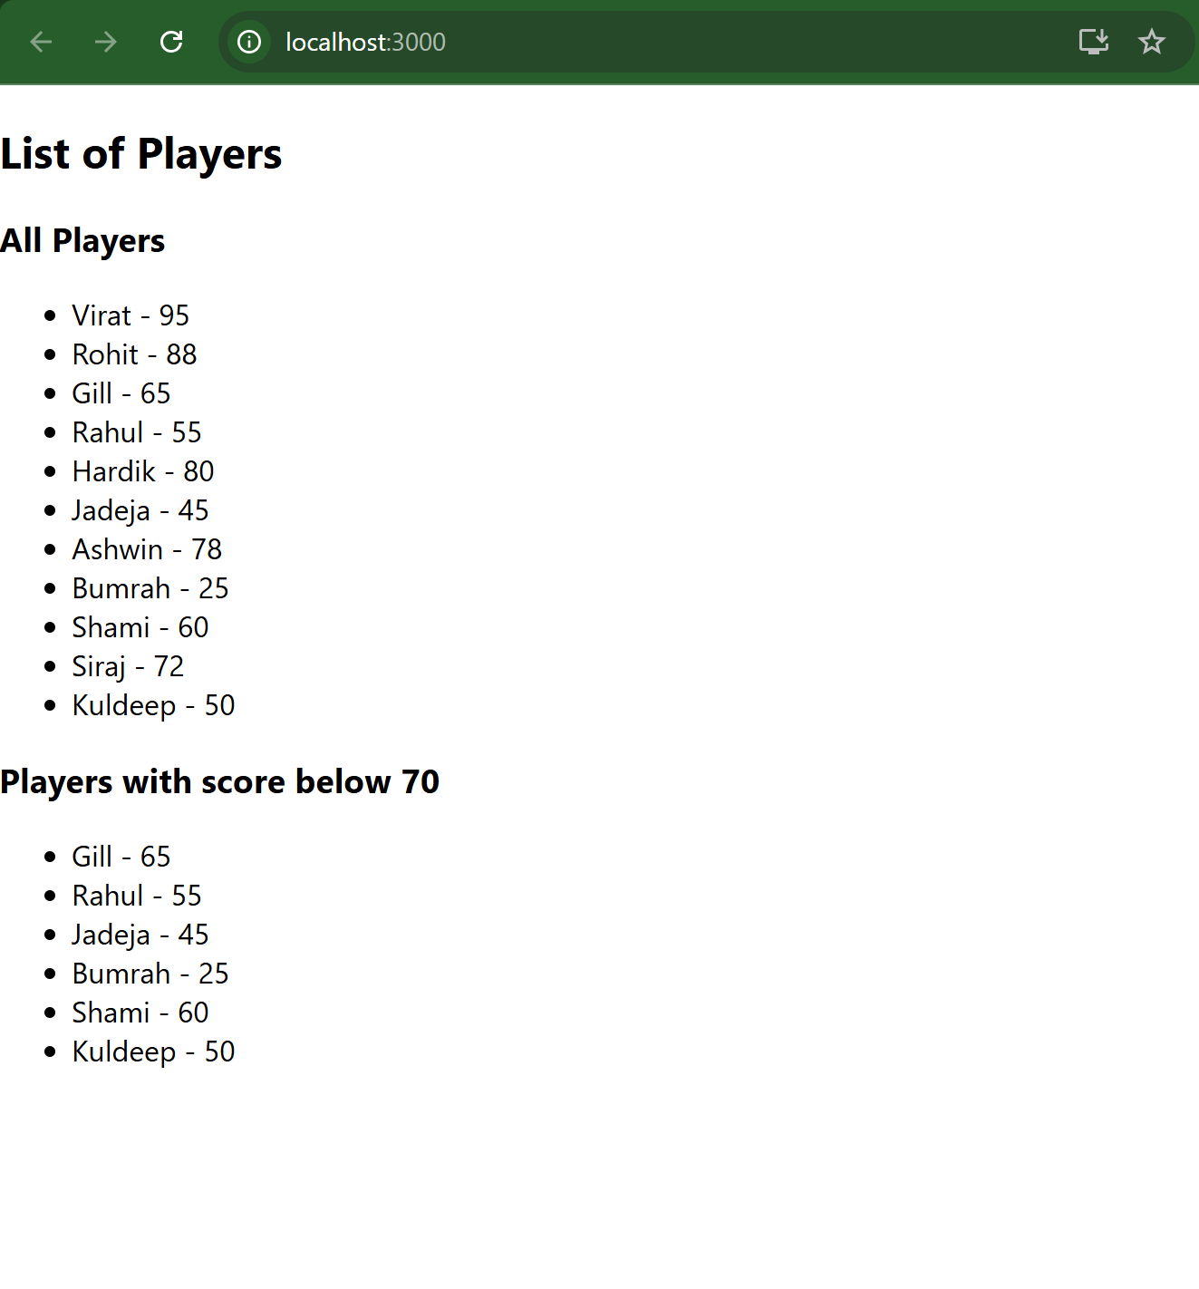

Flag=false
